MD Kalim Anwar | 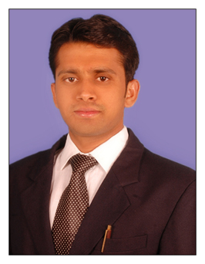
  337, Zafrabad, Delhi-110053
  Cell: +91-7877846743
  Email-kalimanwar1994@gmail.com

Objective | To succeed in an environment of growth and excellence and earn a job which provides me job Satisfaction and self-development and help me achieve personal as well as organization goals.

Educational Qualification: B.Tech (Mechanical Engineering)
Exam/ Degree | Year | Name of institute | University / Board | Stream | Percentage
B.Tech | 2016 | RCERT Jaipur | Rajasthan University. | Mechanical | 60%
Intermediate | 2012 | Sri Goenka College Sitamarhi | Bihar Intermediate Council Patna. | Science | 57.04%
Matriculation | 2010 | Janta High School | Bihar School Examination Board Patna. | General | 62.80%

TECHNICAL SKILLS:
1. Training in hydraulics and automation from prolific company PUNE
2. Auto Cad and Solid work from CAD CENTER
3. Basic knowledge of computer handling in documentation and networking

ACHIEVEMENTS & AWARDS:
World record certificate in mini robots

EXTRA CURRICULAR ACTIVITIES:
- Participation in national conference in our college campus and seminar on review on minimization of operating cost in mining industry by using linear programming.
- Participation in cultural fest.

Personal Skills
- Comprehensive problem solving and numerical abilities.
- Excellent analytical, verbal and written communication skills.
- Comprehensive logical reasoning and result orientation.
- Excellent Management and Team handling skills.
- Very Innovative, motivated and a team player.

PERSONAL INFORMATION:
Father’s Name: Md Motiur Rahman
Father’s Occupation: Ex-Pacs Manager Central Co-operative Bank
Mother’s Name: Naseema Khatoon
Mother’s Occupation: House wife
Date of Birth: June 05, 1994
Gender: Male
Nationality: Indian
Marital Status: Single
Passport No-P1266516
Languages known: English, Hindi, Urdu & Arabic.

Declaration:

I do hereby declare that the particulars of information and facts stated herein above are true, correct and complete to the best of my knowledge and belief and I bear the responsibility for any discrepancy.

Place: MD KALIM ANWAR
Date :

